Communications activity– quarterly report – October to December 2013

Background

- In April 2013, we presented and published our Communications Strategy 2013-14 to the Leadership Board. It outlined our key targets, which included a target to deliver high quality communications activity which is 75 per cent proactive, with a clear focus on national media.

- Our aim is to position ourselves as the ‘come to’ organisation on all matters which affect local government. When it is necessary to react to events, stories or announcements, we will ensure the LGA provides a strong voice for local government, defending the sector’s position.

Media activity October to December 2013

- The following sets out all quarterly media coverage since April 2013.

 | APRIL – JUNE 2012 | APRIL – JUNE 2013
Mentions (all) | 5179 | 4729 (- 8%)
National (print, online, broadcast) | 105 | 306 (+191%)
 | JULY – SEP 2012 | JULY – SEP 2013
Mentions (all) | 3789 | 5931 (+56%)
National (print, online, broadcast) | 101 | 305 (+201%)
 | OCT – DEC 2012 | OCT – DEC 2013
Mentions (all) | 4971 | 6563 (+32%)
National (print, online, broadcast) | 127 | 256 (+101%)
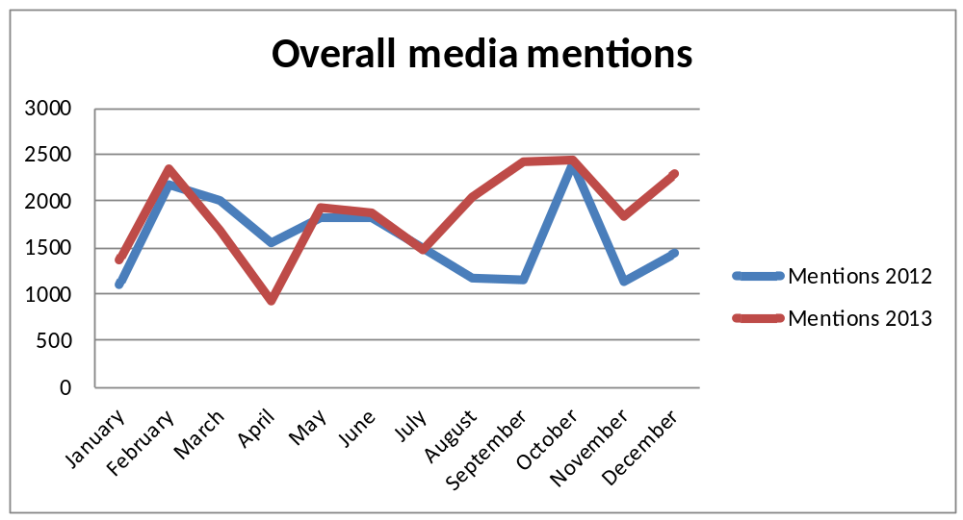

- This quarter saw another significant increase in national media coverage compared to the same period in the previous year (up 101 per cent). This follows a 201 per cent increase between July and September 2013 and a 191 per cent increase between April and June 2013.
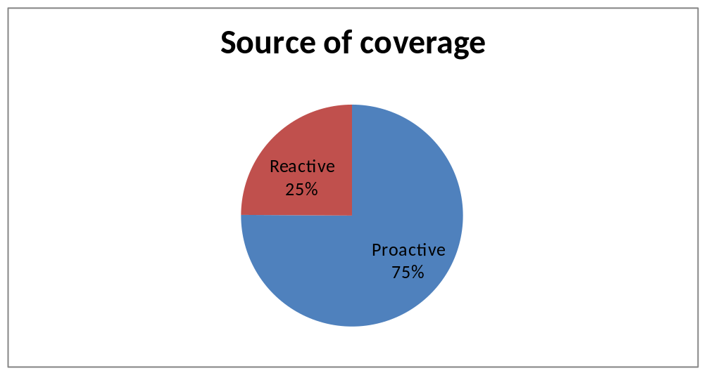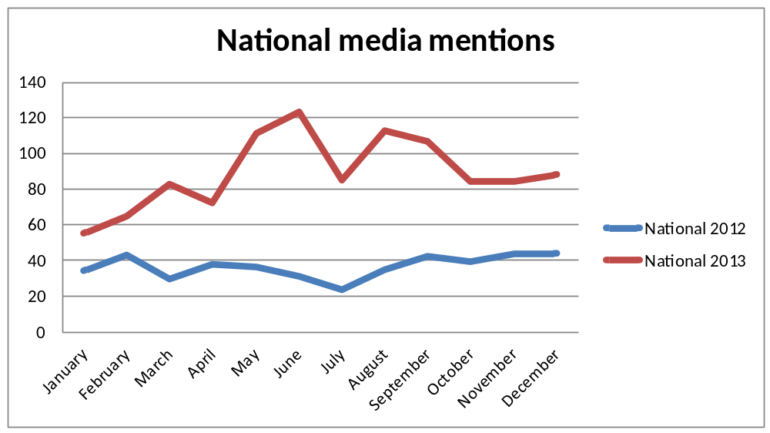

- 75 per cent of LGA coverage this quarter was through pro-active work. 50 separate pieces of coverage were generated through our media work around the Autumn Statement and Local Government Finance Settlement.

- Other proactive releases included:
- Local authorities prepare for extreme weather (24 pieces of coverage)
- LGA response to the Autumn Statement (9 pieces of coverage)
- LGA: Let councils lead on energy schemes (6 pieces of coverage)
- Motorists pay over £1,000 a year in taxes (5 pieces of coverage)
- CCTV parking camera ban will put children at risk (5 pieces of coverage)

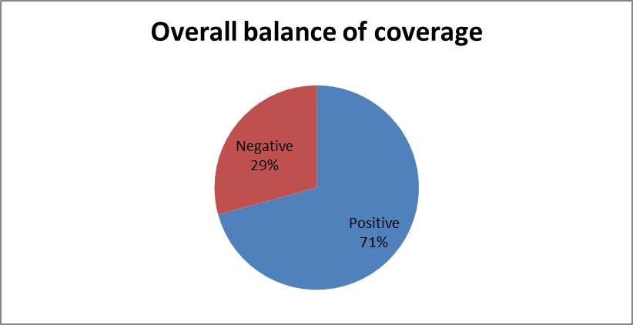

- 71 per cent of our coverage this quarter was positive. This was led by pro-active work around the Autumn Statement and Local Government Finance Settlement which included releases on a national care loans scheme and calling for the Government to lift the housing borrowing cap. We also issued pro-active releases on winter readiness and as councils responded to the storms that hit the country. Reactive work included rebutting criticism around parking charges and the use of bailiffs.
Print and online media

- 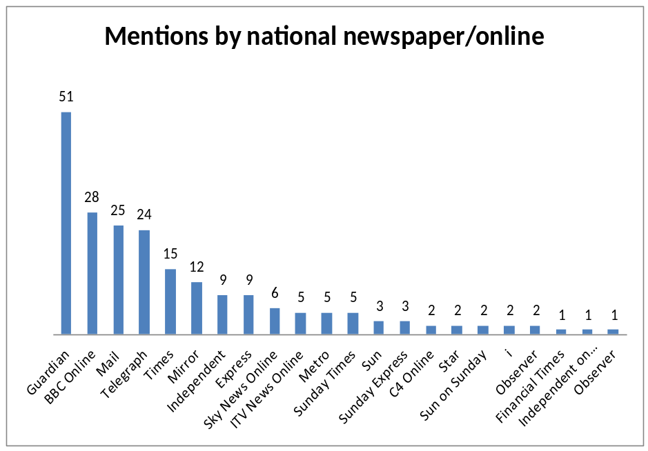The following sets out national newspaper and online coverage for the period October to December 2013.

- 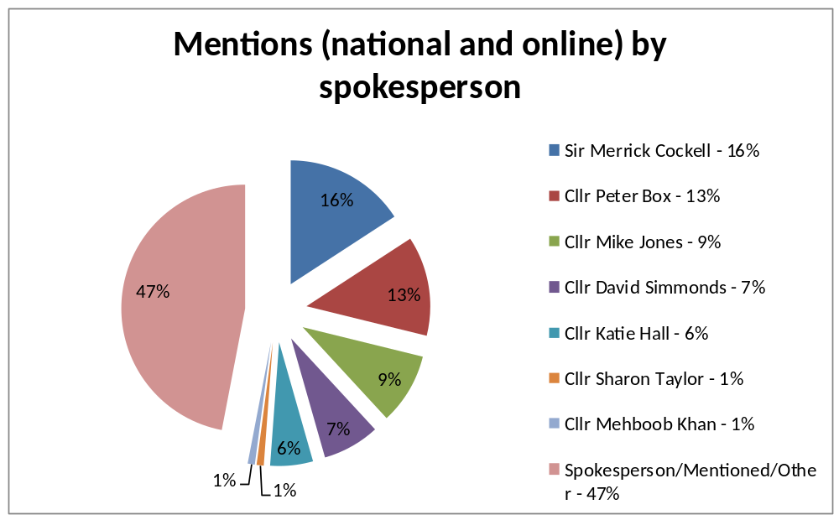The LGA appeared in the majority of national daily and weekend newspapers and online broadcasters and featured in the Guardian 51 times this quarter including a high volume of articles reporting our Autumn Statement media releases. They were also reported widely by BBC Online (28 mentions) while the Mail (25 mentions) leapfrogged the Telegraph (24 mentions) into the top three.

Broadcast media

- The following sets out broadcast activity for the period October to December 2013.

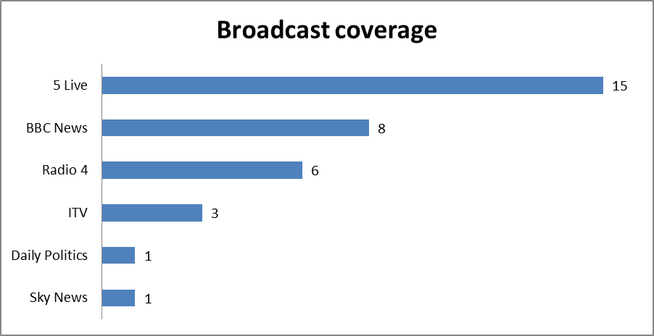
- Our media work saw coverage 34 times on national TV and radio this quarter. December was our busiest broadcast month with 13 stories over 6 different channels and programmes.

- Sir Merrick Cockell returned to the BBC Daily Politics programme in December to discuss the LGA’s call to scrap the Barnett Formula while also talking about the issue on BBC Radio 5 Live.

- Cllr Mehboob Khan and Cllr David Simmonds covered half of all LGA broadcast interviews this quarter discussing a range of topics from parking charges on Sky News, adult social care funding on BBC News and potholes on ITV Daybreak.

- Cllr Peter Fleming appeared on BBC Radio 4 You and Yours to discuss collective switching and appeared on ITV Daybreak to talk parking charges.
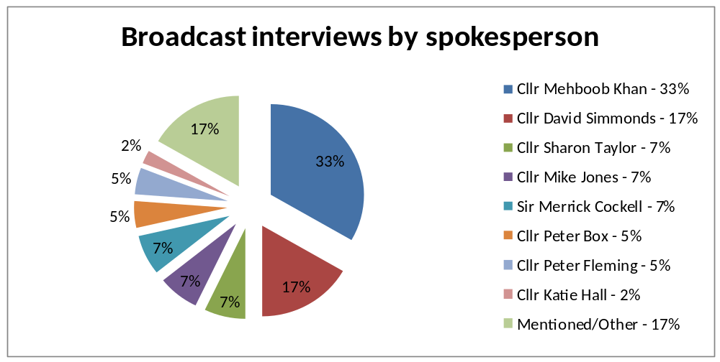

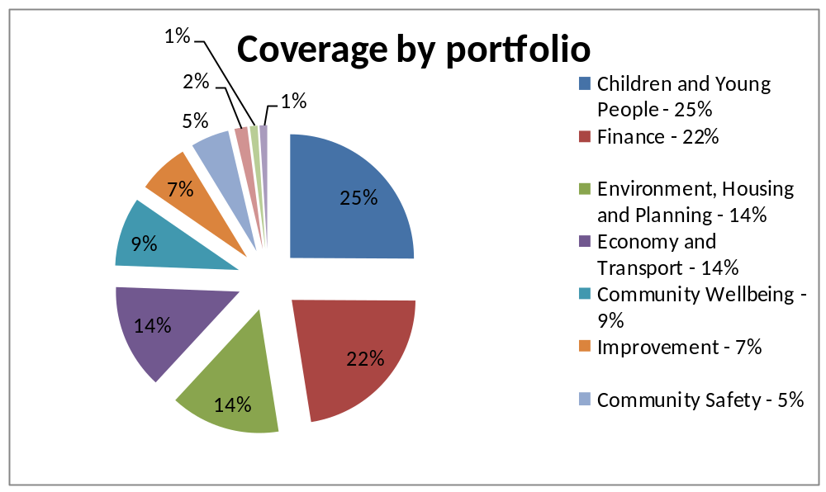

- The majority of our coverage this quarter was positive. Negative Children and Young People coverage came from criticism around housing homeless teenagers in B&Bs, care leaver support, Ofsted warnings around children missing from mainstream education and a report into CSE from the Children’s Commissioner. Community Wellbeing included reports on 15 minute care visits, care worker minimum wages and the progress of the Winterbourne View Joint Improvement Programme. For Economy and Transport it was around parking charges, Environment, Housing and Planning was on criticism around collective switching progress and councils’ use of Discretionary Housing Payments. In Finance it was on the use of bailiffs and council tax arrears.

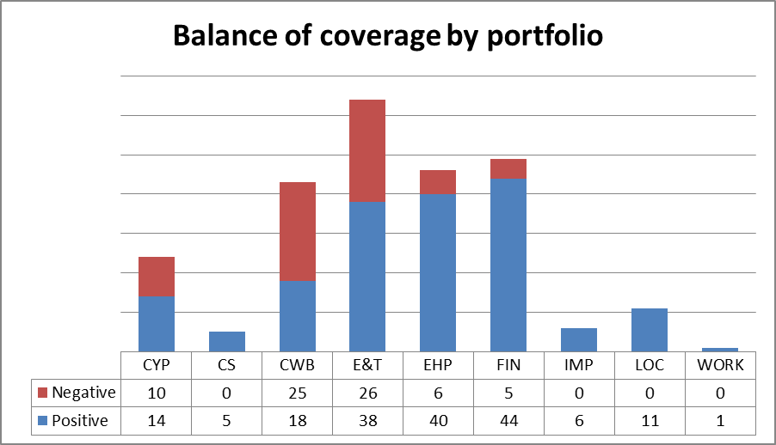

Public affairs activity

- From 1 October to 31 December 2013 there were 204 mentions of the LGA in Parliament.

- During this period we have submitted written evidence to eight separate Select Committee inquiries, and offered oral evidence on seven occasions.

- In addition to Select Committees, we have issued more than 40 parliamentary briefings on LGA campaigns or ahead of debates in both Houses.

Legislation

- On the Pensions Bill, we briefed Peers about the financial impact of the legislation. Ahead of Second Reading and Committee Stage in the House of Lords, the LGA met with Peers, including Lord Whitty (Lab), Lord German (Lib Dem) and Baroness Eaton (Con), and issued briefings to Peers from all political benches. Our concerns were raised on the floor of the House and as a result Treasury Minister Lord Freud has offered to meet LGA Chairman Sir Merrick and officials at a round table for further discussions.

- We secured a significant success during the House of Lords Report Stage of the Children and Families Bill when the Government curtailed a power in the Bill to remove all local authorities from adopter recruitment by accepting an amendment requiring an active debate and vote in both Houses of Parliament before its use. This was in addition to an earlier concession delaying its implementation until 2015. The LGA has briefed Peers (including Shadow Education Minister Baroness Hughes) and civil servants and issued briefings to raise awareness of the issue and push for an amendment. The LGA has also been briefing Peers on the Bill’s Special Educational Needs clauses. Although yet to be debated, a government amendment has already been introduced and significantly alleviated LGA concerns.

- We met with the Electoral Commission during the last quarter to discuss the Transparency of Lobbying, Non-party Campaigning and Trade Union Administration Bill, and the potential impact on the LGA. The LGA also made representations to Greg Clark MP in the Cabinet Office (17 October). The ministerial response (17 November) confirmed that lobbying activity conducted by councillors will not be captured by the Bill unless they are undertaking the work as paid lobbyists. The letter from the Minister also offered reassurance that the LGA will not itself be covered by the legislation. Reassurances were also received from the Deputy Prime Minister’s office.

- Cllr David Simmonds and Paul Raynes gave oral evidence to the Draft Deregulation Bill Committee on 4 November. The Chairman also co-signed a letter (25 November) with Westminster Council to Oliver Letwin MP, copied to the Committee, recommending that the Bill allows councils to recommend unnecessary or outdated legislation for review and repeal.

- Local Audit and Accountability Bill - since 1 October we have issued briefings to MPs ahead of Second Reading, Bill Committee, Report and Third Reading stages. We have met with and briefed various MPs including Shadow Secretary of State for Local Government Hilary Benn MP and Shadow Minister Andy Sawford MP (both Lab) as well as backbenchers such as Andrew Stunell (Lib Dem), Heather Wheeler MP, George Hollingberry MP and Mark Pawsey MP (all Con). Our engagement has focused on supporting amendments to the proposals around council tax referendums and the Local Government Publicity Code. We also delivered a key win for the sector by persuading the Government to introduce an amendment to allow councils to be able to continue to procure external audit nationally. We estimate this could save the public purse more than £200 million over a five year period.

- The Care Bill - we briefed ahead of the final stages in the House of Lords, including Report and Third Reading, and ahead of the Second Reading in the House of Commons on 16 December. Our focus has centred on social care funding, our recommendation for a deferred payments system, and a secure funding framework for the Care and Support Programme Board.

- We have also been working on the Local Government (Autonomy) Bill, a Private Members Bill which seeks to provide a statutory foundation for local authorities in England and Wales. The Bill has been drafted and discussions held with Lord Wills (Lab) who has agreed to lead on the legislation within the House of Lords. The LGA is working with Lord Wills to ensure the Bill is tabled in the New Year.

- Anti-social Behaviour, Crime and Policing Bill - meetings have been held with Baroness Smith of Basildon, Lord Beecham (both Lab LGA Vice-Presidents) and Lord Rosser (Lab) to discuss our concerns. Briefings have also been provided to Peers across all political benches during Committee stage of the Bill, which has been taking place in the Lords over recent months.

- The Business, Innovation and Skills Select Committee has been conducting pre-legislative scrutiny of the Draft Consumer Rights Bill. We wrote to the Minister for Consumer Affairs, Jo Swinson MP, raising concerns that the Bill could weaken the ability for councils to tackle rogue traders by reforming powers of entry and potential minimum competency standards for officers. A similar letter was sent to the Chair of the BIS Select Committee, Adrian Bailey MP, to inform the inquiry. A meeting was also held with Ann McKechin MP (Lab) to discuss her concerns on the need for national competency standards, an issue she had brought up during the committee sessions on the Bill.

Select Committees

- Cllr Ed Turner gave oral evidence to the Environmental Audit Select Committee on 9 October as part of an inquiry into housing standards, following on from written evidence previously submitted. The resulting report from the Committee (20 November) recognised the role of councils in driving up the quality of housing and the need for local areas to have a say on standards, whilst raising concerns, that current government proposals put this at risk.

- Cllr Sharon Taylor gave evidence to the Work and Pensions Select Committee (16 October) as part of an inquiry into the role of Jobcentre Plus in the reformed welfare system. Cllr Taylor also gave evidence to the Committee (18 December) as part of a separate inquiry into support for housing costs in the reformed welfare system.

- Head of Productivity Brian Reynolds gave oral evidence (28 October) to the Communities and Local Government Select Committee on local government procurement.

- Cllr Robert Light gave oral evidence to the Education Select Committee as part of an inquiry into Residential Children’s Homes (6 November). We also offered written evidence to the Committee’s inquiry into academies and free schools (19 December).

- Cllr Mike Haines gave oral evidence to the Transport Select Committee (11 November) on councils’ preparations for winter weather. This followed written evidence (7 October). The Select Committee was also provided with a copy of the findings from our 2013/14 Winter Readiness Survey of local authorities. We issued three further written submissions to the Transport Select Committee in response to inquiries being held on the strategic road network (16 October), local decision making on transport expenditure (9 December), and cycling safety (25 November).

- Cllr Katie Hall and Andrew Webster gave evidence (20 November) to the Health Select Committee on public expenditure on health and social care.

- We submitted written evidence (4 December) to Home Affairs Select Committee’s inquiry on “Police and Crime Commissioners: One Year On”.

- We submitted written evidence to the Public Administration Select Committee inquiries on crime statistics (12 November) and citizen and public services (1 November).

All Party Parliamentary Groups

- Cllr Tony Ball gave oral evidence (3 December) to a parliamentary inquiry into boosting youth employment and training following construction and housing investment. We previously submitted written evidence to the inquiry, which is being chaired by Lord Best (Crossbench, LGA Vice-President) and Nick Raynsford MP (Lab, Greenwich and Woolwich) and supported by the Chartered Institute of Building. At the request of the parliamentarians, we are currently canvassing local authorities for case studies to inform the inquiry.

- We met with representatives of the All-Party Parliamentary Group on Skin (17 December) to discuss potential licensing of sunbed salons by local authorities.

Other parliamentary briefings

- Local government has been well represented on the subject of local government finance in both parliamentary chambers. Working with colleagues across the organisation, on the day briefings were issued on both the Autumn Statement (5 December) and Local Government Finance Settlement (18 December). Ahead of these key dates, we briefed MPs on local authority funding for debates in the House of Commons (10 October, 23 October, and 3 December) with our arguments and figures heavily quoted on each occasion. We also briefed Peers for a debate in the House of Lords (17 December) on the need for reform of the Barnett Formula and a fair funding settlement across all UK nations, which had been tabled by Lord Shipley.

- Economic growth - we briefed MPs on the role of local authorities in shaping their high streets ahead of two House of Commons debates (16 October and 28 November); on planning and housing supply for a Westminster Hall debate (24 October); and on business rates ahead of an Opposition Day debate on the same subject (4 December). Our arguments and positions were referenced in all debates.

- We briefed parliamentarians ahead of a House of Commons debate on housing benefit (12 November) and a House of Lords debate on fracking (19 November).

- The LGA briefed MPs for an Opposition Day Debate on childcare (19 November). We also briefed Ian Mearns MP (Lab, LGA Vice President) ahead of his Westminster Hall debate (19 November) on the oversight of free schools.

Other meetings

- In addition to linking all parliamentary briefings and submissions to the Rewiring Public Services campaign, we briefed stakeholder organisations on the recommendations. Between 1 October and 31 December this included meetings with: Living Streets, the NHS Confederation, the Campaign to Protect Rural England, the Co-operative Group, Macmillan Cancer Support, PwC, RSPCA, Age UK, the Kings Fund, and Zurich Municipal.

- The Chairman met Chris Grayling MP (Secretary of State for Justice); Kris Hopkins MP (Parliamentary under Secretary of State for Communities and Local Government); Jo Johnson MP (Head of No. 10 Policy Unit); and Baroness Stowell (Parliamentary under Secretary of State for Communities and Local Government).

- Other briefings held with parliamentarians between 1 October and 31 December, include Chris Evans MP (Lab, on Rewiring Public Services), Jim Dowd MP (Lab, on Rewiring Public Services), Therese Coffey MP (Con, on the spare room subsidy), Nick Herbert MP (Con, on Local Plans), Martin Horwood MP (Lib Dem on Local Plans), Gisela Stuart MP (Lab, on local government finance), Mary Creagh MP (Shadow Lab Secretary of State for Transport, on parking fines), Lord Shipley (Lib Dem, on local government finance), and Baroness Eaton (Con, on local government procurement), as well as a number of parliamentary advisers.

Other events

- We organised a Smith Square Debate entitled “The big debate: Can local public services be rewired?” chaired by Mayor Dorothy Thornhill. Speakers included LGA Chairman Cllr Sir Merrick Cockell; John Redwood MP (Chair of the Con Economic Affairs Committee); Andy Sawford MP (Shadow Minister for Local Government) and Ben Page (Chief Executive of IPSOS Mori). Ninety-seven councillors, officers and stakeholders attended, to hear from the panel on the recommendations within Rewiring Public Services on how best to meet future funding challenges.

- We organised two roundtable events to discuss whole person integrated care. The first (9 October) was held in Parliament and chaired by Shadow Secretary of State Andy Burnham MP, with the Shadow Minister Kiz Kendall also present. Attendees included senior local government officers and members. The second (2 December) was held in Local Governemnt House and offered an opportunity for senior local government officers and members to contribute to Sir John Oldham’s commission into the future of care. Sir John and members of his team were present.

Digital communications

- Website statistics October to December 2013

Visits: 275,048
Unique visitors: 182,734
Page views: 1,061,773

Number of page views up from the last quarter (1,009,318) however a small decline in visits (295,570) and unique visitors (188,011). 55.9 per cent of visitors were new to the website.

- Subscriptions went up for all bulletins except Children and Young People, which went down by 51, Improvement and Innovation, which went down by 20, and Workforce which went down by 23.

Figure 1: number of e-bulletin subscribers
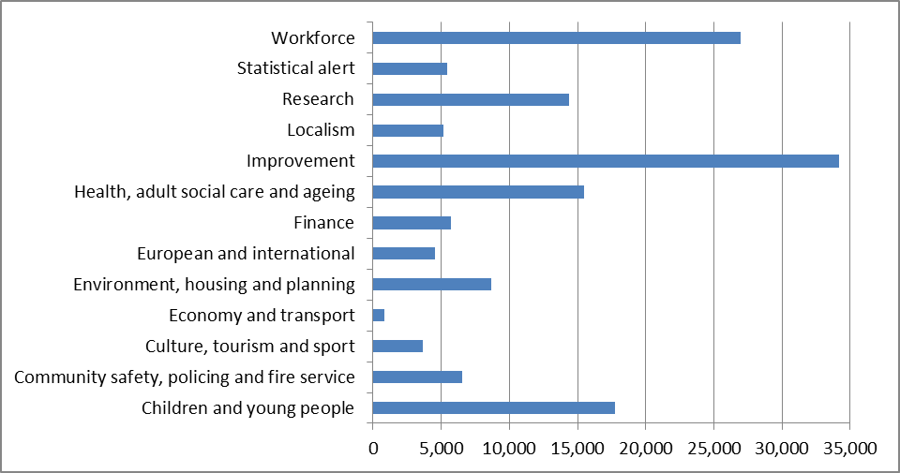
Notes:
(1) Localism and Economy and Transport e-bulletins are relatively new and the percentage increase month-on month is amongst the highest.
(2) The Improvement e-bulletin is an amalgamation of several previous e-bulletins that existed before the rationalisation, hence the large subscriber numbers.
(3) The workforce e-bulletin is sent infrequently compared to other bulletins.

